MQ 2019 January BOM
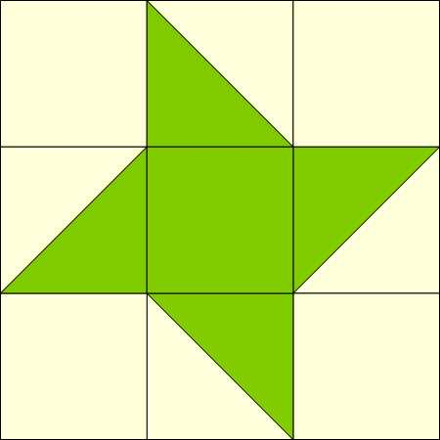

Make ONE 12 inch (finished) 12 ½ “( unfinished) block |  |  | Make TWO 6 inch (finished) 6 ½( unfinished) blocks
Light Fabric | Dark Fabric |  | Light fabric | Dark Fabric
A (4) 4 ½’’ | A (1) 4 ½ “ |  | A (8) 2 ½” | A (2) ½”
B (2) 5” | B (2) 5” |  | (B 4) 3” | B (4) 3”

To make Half Square Triangles: Lightly draw diagonal line on back of light B squares. Lay one light square on top of one dark B square. Sew ¼ inch on either side of drawn line. Press to dark fabric.
For the 12 inch block, trim the HST’s to 4 ½”. For the 6 inch blocks, trim the HST’s to 2 ½ “. Sew into rows, then rows together.
You may sew the two six inch blocks together, but don’t sew onto the twelve inch block yet. You may want to move them around when you get them all made.

