MQ 2019 June BOM
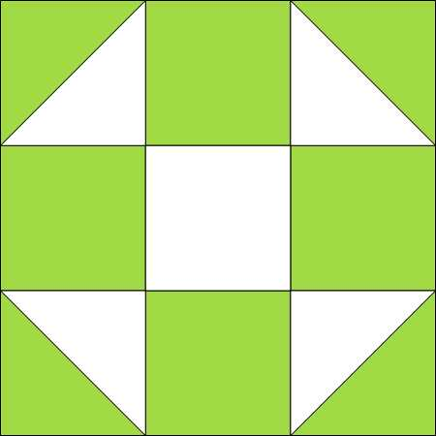
Shoo Fly
Make ONE twelve inch block (12 ½” unfinished).
Light | Dark
(A) Cut two 5 ¼” squares | (A) Cut two 5 ¼” squares
(B) Cut one 4 ½” square | (B) Cut four 4 ½” squares

Make TWO six inch blocks (6 ½” unfinished).
Light | Dark
(A) Cut four 3 ¼” squares | (A) Cut four 3 ¼” squares
(B) Cut two 2 ½” squares | (B) Cut eight 2 ½” squares

Use ‘A’ light and dark squares to make Half Square Triangles. Lay one light square on top of one dark square. Draw a faint line diagonally. Sew ¼ “on both sides of the line. Cut on drawn line. Press to the dark.
For 12 inch block, trim HST’s to 4 ½.”
For 6 inch blocks, trim HST’s to 2 ½.”
Use light ‘B’ fabric for center square. Use dark ‘B’ fabric for top, bottom and side squares.
Follow diagram to sew into rows, then sew rows together.

